Review Assignment – Methods of Factoring:

Provide an example for each method (you may use your notes, homework, or textbook to help find examples)

- Look for a greatest common factor and factor it out in front.
$$4x^{2}-2x=2x(2x-1)$$

Example: (use a polynomial of degree 3 for your example and factor it fully)

- Factor a quadratic, $x^{2}+bx+c$, by looking for two numbers that multiply to c and add up to b.

Example:

- For a quadratic with a negative leading coefficient, ${-x}^{2}+bx+c$, factor the negative out in front, $-(x^{2}-bx-c)$ and then continue factoring the quadratic.

Example: (once you pull the negative out make sure you factor your quadratic fully)

- For a quadratic where the leading coefficient cannot be factored out, $ax^{2}+bx+c$, find factors of a and factors of c that when multiplied together add up to b.

Example:

- Follow the difference of squares method:
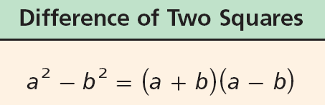
$$x^{2}-4=x^{2}-2^{2}=\left(x+2\right)(x-2)$$

*And this method can work for other numbers if you use square root:
$$x^{2}-3=x^{2}-{\sqrt{3}}^{2}=\left(x+\sqrt{3}\right)(x-\sqrt{3})$$

Example: (use a quadratic with a leading coefficient greater than 1 for your example)

- To factor a polynomial, find the zeros by setting the expression equal to zero, solve for x (find the solutions, roots). x minus the root will be a factor, $(x-r)$.
$$x^{2}+4$$
$$x^{2}+4=0$$
$$x^{2}=-4$$
$$x=±\sqrt{-4}$$
$$x=±2i$$

$$x^{2}+4=\left(x-2i\right)(x+2i)$$

Example:

- Factor by grouping

Example:

- Follow the sum and difference of cubes method (SOPPS it up)
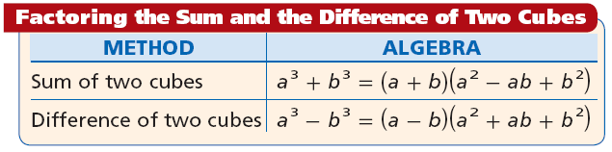

Example:

- Use the rational root theorem (and help from a graphing calculator if necessary) to find the rational roots. Divide your polynomial, $p(x)$, by $(x-r)$ using synthetic division. The quotient, $q(x)$, will be another factor: $p\left(x\right)=\left(x-r\right)q\left(x\right)$. Factor $q(x)$ down to find all the factors of $p(x)$ (either perform synthetic division again for another root, use another factoring method, or use the quadratic formula to find irrational or complex roots).

Example:

